Assignment 5
Roll number: U23AI042
WordCount code running:
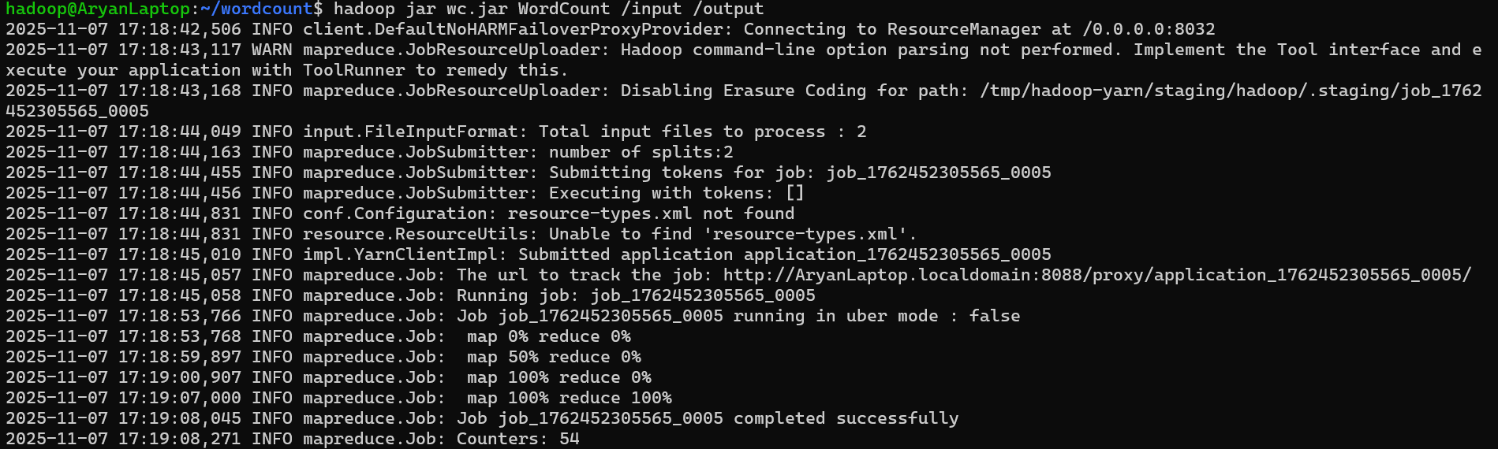
Output:
